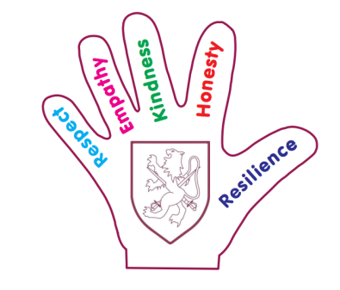
Walter Infant School and Nursery School Development Plan 2019 2021
Targets

To be a safe and healthy environment in which our children can thrive amidst the regulations and precautions in place for COVID 19 so that those risks and risk management become ‘Business as Usual’ for Walter Infant School and Nursery.

Quality of Education
To embed the 3 ‘I’s’ into our curriculum – Intent, Implementation and Impact

To ensure that ALL children make good or better progress from their starting points

Reading and Core Skills are the focus for all teaching and learning for the foreseeable future

Catch up: All children have the opportunity to access catch up resources and funding opportunities where identified.
Behaviours and Attitudes
To review and amend the current behaviour policy in response to behaviour trends and the individual needs of some of our most vulnerable children or those children who present with behaviours that are challenging.

Personal Development
To ensure that children are well prepared for the next stage of their education journey and that they are confident in articulating their personal challenges and successes.

Leadership and Management
All leaders (including the Governing Body) will ensure that the well-being of staff is paramount and that we are aware of any barriers preventing a good work life balance and good mental health for staff at all levels.

All children will receive the care and support they need to feel safe, secure and happy in school and ready to learn

Safeguarding:
To ensure that any safeguarding concerns are followed up without delay and all procedures followed using the new safeguarding flow chart.

