Walter Infant School
PE and Sport Premium Statement
2019/20

The school’s allocation for the academic year 2017/18 was:
September 2017 – March 2018 - £10,383
April 2018 – August 2018 - £7,417

The school’s allocation for the academic year 2018/19 is:
September 2018 – March 2019 - £10,383
April 2019 – August 2019 - £7,417

The school’s allocation for the academic year 2019/20 is:
September 2019 – March 2020 - £10,383
April 2020 – August 2020 - £7,417

We use our funding to hire a professional coach, and his team, to work alongside our teachers to ensure sustainable improvements to the quality of PE and Sport at Walter Infant School.

Our professional coach, Jack Dillon, has provided existing and new staff with training and support to teach PE and sport more effectively. He runs a rigorous programme of meticulously planned lessons and schemes of work to ensure that the children have every opportunity to develop their skills in all aspects of physical education.

The children learn to develop their sending and receiving skills; they learn to use a variety of equipment such as footballs, tennis racquets and cricket bats correctly. They play games to develop their reactions and their hand and eye co-ordination. They learn to travel and balance in different ways and to use bi-lateral movements, for example, moving from side to side to dodge and swerve as part of a tactical game.

The children also learn strategies for fair play and good Sportsmanship; they learn to take turns, to appreciate each other’s efforts and achievements and they also develop their understanding of ‘Team Spirit’.

Ofsted Inspectors reported that:

“The school makes good use of additional funds to promote physical education and sport through the deployment of a specialist coach who is well-known to the school and has a very positive rapport with them. This results in pupils having a very positive attitude towards healthy lifestyles and ensures that they all take part in regular sport of a good standard” Ofsted November 2013

As a professional coach, Jack upholds the values of the school; he has high expectations for behaviour and supports the children who present with a greater need than others to enable them to succeed.

Jack has begun to organise sporting competitions and our football team has taken part in an inter-schools competition.

As a result of our investment we have successfully developed:

- Achievement in weekly PE lessons
- Increased participation in sport
- Personal health and well-being
- Improved Attitudes and Behaviours for Learning (BfL)

Achievement in Weekly PE Lessons
PE lessons have been enhanced by the use of specialist sports coaches since September 2013. Our qualified teachers work alongside Jack in one of their two PE lessons each week ensuring that good practice and high expectations to succeed are maintained in all PE lessons.

Increased Participation in Sport
As the children’s skills develop further, they are much keener to be involved in extra-curricular clubs, sports day events and playground activities such as basketball and football. We have increased our provision of extra-curricular activities at the beginning and end of the school day as well as lunchtimes to meet the greater desire for children to take part in sporting activities.

Personal Health and Well-being
Offering wider opportunities to participate in sporting activities raises the profile of PE at our school and supports the health and well-being of all our children.

‘Improved Attitudes’ and ‘Behaviours for Learning’
We believe that the skills of teamwork, collaboration, co-operation and perseverance, which are developed through sport and PE, will have a positive impact on the attitudes and learning of pupils across the curriculum.

Small Group sessions for pupils with additional needs
Some children will present with a specific need, for example poor hand and eye co-ordination, making sending and receiving more difficult, for example throwing and catching a ball. These children are supported by additional small group sessions led by Jack Dillon and supported by a learning support assistant to enable them to develop their skills and to feel more confident in whole class sessions.

Sports Star of the Week
Jack chooses a Sports Star of the Week (in line with our star of the week certificates for children who have excelled in attitudes and behaviours). This encourages participation and sportsmanship for all children; the children are also encouraged to coach and support their classmates.
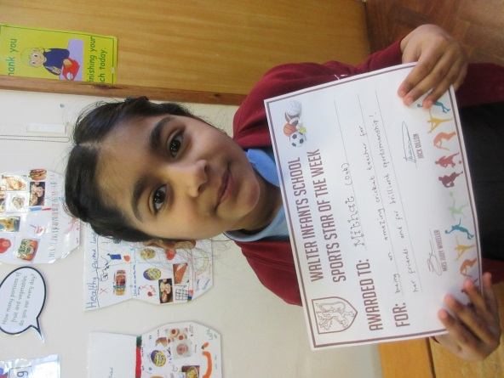

We have continued to use some of our funding allocation to improve the outdoor facilities for our young children; we now have three running tracks for the children to use during playtimes and lunchtimes to increase their levels of fitness. In addition to this, we have improved the playground surfaces, where we can. Our PTA raised a significant amount of money towards a climbing frame designed to develop physical dexterity and upper body strength; we toped up the money raised to ensure we could have the best possible equipment and safety surfaces. In 2019 we received our Healthy Schools Award and were also awarded a cup for being the most sustainable large primary school in Wokingham, due to our healthy approach to travelling to school, with many of our children walking, running, scooting or cycling, so we feel we are really making an impact on developing healthy minds and healthy bodies.

We have also spent an additional amount of money of our sports provision in school this year and will continue to do so: the children really enjoyed Maypole Dancing, Tennis Coaching and our second World Dance Day!

