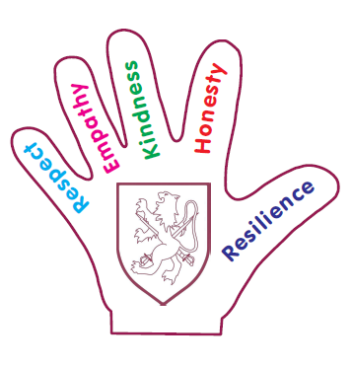
KINDNESS
“If you are playing with something, it is kind to share.” Fraser
“If you are kind, people will be kind to you too.” Ralphie
“Kindness makes the world a happy place.” Sreeja
“If you are kind to someone it will make them happy.” Harshita
“I let others talk before me. “ Rylee
“When my friends are sad I let them play whatever they want.” Aston
“You can feel proud of someone for doing something kind.” Harriet

