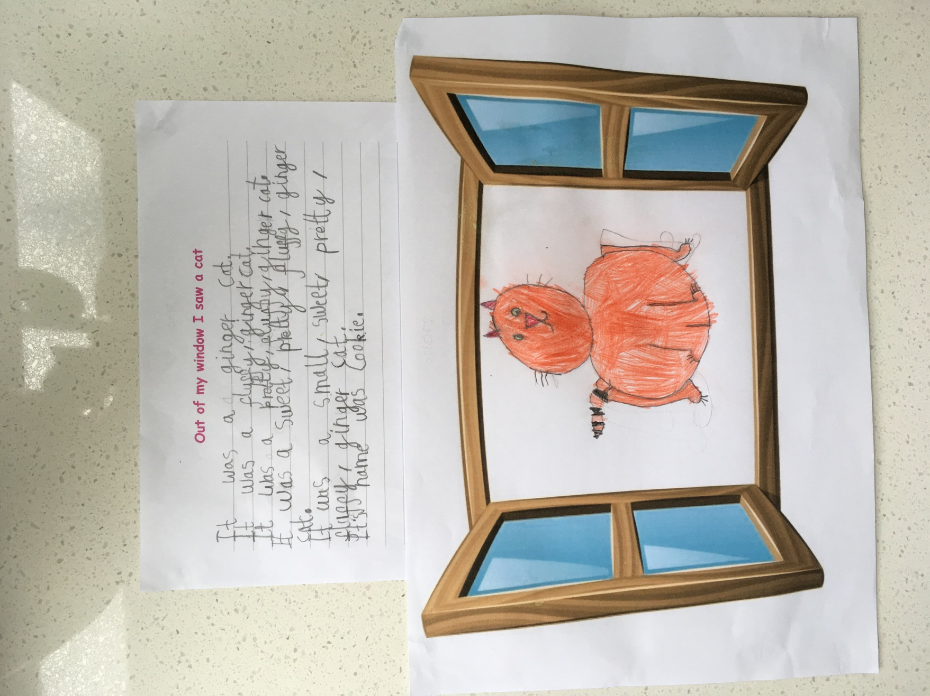

This is an absolutely wonderful poem, written at home by Laila. Well do Laila you have used such excellent adjectives and followed the pattern of the poem. Thank you ☺ The commas in our list are exceptional.