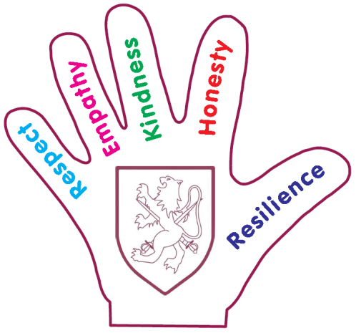
Walter Infant School and Nursery

Bullying Behaviour in School

As you know, we take bullying behaviour concerns very seriously; all our staff have received ABA (Anti-bullying Association) training so that we can ensure our children know what bullying behaviour is and what to do about it. The children understand that bullying behaviour is repeated behaviour, so happens more than once. In our Anti-bullying and Equality Policy it clearly states that:
“We define bullying as the repeated and deliberate action by an individual or a group that is an attempt to control/have power over an individual. A conflict between two equals is not considered bullying.
The school does not typically interpret these situations as bullying:
- Naturally boisterous behaviour
- The tendency to boss whoever is around
Bullying can be:
- Physical – hitting, kicking, taking belongings
- Verbal – name calling, insulting, making offensive remarks
- Indirect – spreading nasty stories about someone, exclusion from social groups, being made the subject of malicious rumours.
Bullying may include discrimination, harassment and victimisation and may be associated with race, disability, Special Educational Needs, sex, religion or belief, sexual orientation, or other vulnerable groups.”

The children at Walter Infant School and Nursery are extremely kind and considerate of others; they reflect our values in all their behaviours and I am delighted to say that we have had no bullying incidents this year.
