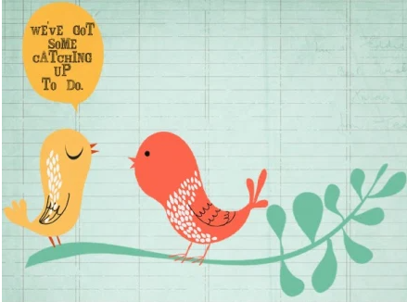

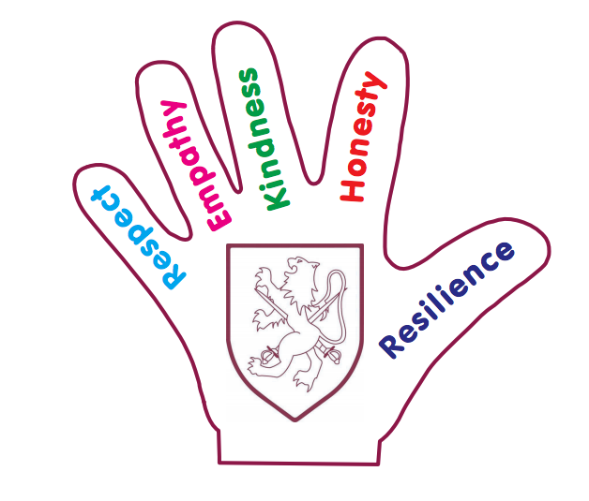
Walter Infant School and Nursery
Catch Up Plan
September 2020 ~ July 2021
School Development Plan 2020
Catch Up: All children have the opportunity to access catch up resources and funding opportunities where identified
We have identified the children in every year group who meet the following criteria:
- Children who are our lowest 20% for attainment
- Children who have moved backwards from our previous assessments (March 2020) from either Greater Depth (GD) to Working AT (WA) or from Working AT (WA) to Working Towards (WT) or from Working Towards (WT) to Emerging (E)
- Children who have not met social and/or emotional milestones (including in some cases self-care)
- Children who have joined our school and are Working Towards the Expected Stand on below without an identified Special Educational Need or Disability
- Children with English as an Additional Language as a new beginner may meet the requirements for Catch Up provision

We made the decision to use our books (Learning Journeys) as a record for baseline, regression, progress and attainment; along with observations and dialogue.

We knew we needed to start teaching immediately so would be using continuous summative assessments in all cohorts in September.
We used our March 2020 tracking data as our starting points in September. Our December PITAS will measure any progress made.

Every child on our catch-up register has a personalised Catch Up plan; designed by the class teacher based on the teaching and learning needs.

These plans will be visited regularly to monitor progress and to review targets.

Our BIG Curriculum!

Walter Infant School and Nursery is an equitable, safe, secure and happy place to learn; our children grow as individuals in a stimulating and exciting environment which values respect, empathy, kindness, honesty and resilience.

Walter Infant School and Nursery is a larger than average three form entry infant school with a 52 place nursery; we consider ourselves to be a “BIG School for LITTLE PEOPLE”. We have designed a ‘BIG’ curriculum to excite, inspire and foster a desire to learn; we want our children to know more about the world around them and to be happy, confident and successful.

Intent
We want our children to have very positive behaviours for learning and to ask BIG questions and we want our staff team to support our children in finding authentic, age-appropriate answers to questions which stimulate them to want to learn more.

The children will learn through real-life and practical experiences, as well as through wonderful, awe inspiring fiction texts and exciting non-fiction texts. Our children will learn inside and outside the classroom, fulfilling and exceeding the requirements of national age-appropriate curriculums in a stimulating and memorable way.

Therefore, in addition to personalised provision plans (Catch Up Plans) we have invested in new resources, appropriate to the stages of development and the learning needs of all our children who missed out on key learning opportunities in with their previous setting or in their previous year group. We have continued our curriculum offer from the point at which the school was closed to all children. We have adapted our curriculum for Key Stage 1 and Foundation Stage.

In Foundation Stage we follow the: Statutory framework for the Early Years Foundation Stage setting the standards for learning, development and care for children from birth to five.
Development Matters

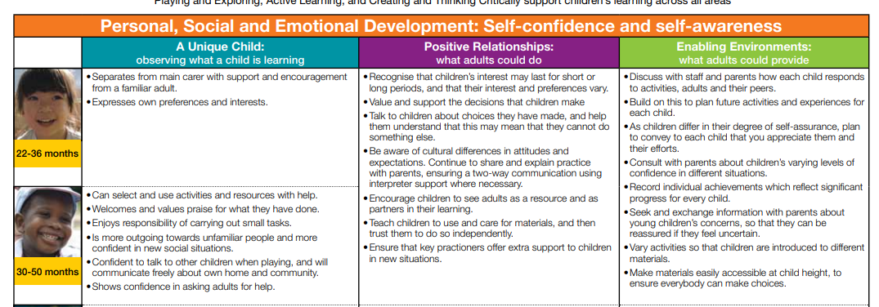

Year Group | Curriculum Starting Point
Foundation Stage 1 | Development Matters 22-36 months
Foundation Stage 2 | Development Matters 30-50 months
Year 1 | Early Learning Goals to achieve a Good Level of Development
Year 2 | Year 1 Curriculum Programmes of Study usually covered in the Summer Term and Expected Standards for the end of Year 1

Foundation Stage 1
Provision | Impact | Leader | Cost
Requirement from EYFS for children aged three and over in maintained nursery schools and nursery classes in maintained schools:  • there must be at least one member of staff for every 13 children We have employed an additional FTE staff member (increasing the hours of our dedicated lunch club leaders) to ensure that we have enough support for the children struggling to adapt or in managing their self-care and ablutions.  • at least one member of staff must be a school teacher as defined by section 122 of the Education Act 200241 Miss Potter is an Early Years Teacher with QTS  • at least one other member of staff must hold a full and relevant level 3 qualification Mrs Jo MaCleod has an NVQ Level 3 in Child Care | December 2020: The children are becoming much more independent and are all making exceptional progress from their starting points.  The children’s behaviours for learning have improved dramatically since starting nursery. Initially some children were very anxious as they had not been separated from their parents since March. Having an additional adult to support class has made a significant difference to the staff and the children. We will continue this ratio of staffing for this year and then evaluate. | Jessica Bennette with support from Samantha Potter | £1531.50 per term (3 months)  Temporary arrangements for this year only  £4594.50
Resources:  We have purchased additional resources to aid children with learning to use the toilet.  We have purchased additional toys for small world play to build on the children’s personal experiences; e.g. dolls house, garage, home corner resources and furniture.  We have also sourced equipment for children presenting the specific needs. | December 2020  Self-Care  More children are coming into school without nappies: 8 in September now 5 (but 1 child who soils her underwear daily) | Samantha Potter | £499.54
Foundation Stage 2
Provision | Impact | Leader | Cost
Reception classes in maintained schools and academies are subject to infant class size legislation. The School Admissions (Infant Class Size) Regulations 2012 limit the size of infant classes to 30 pupils per school teacher (subject to permitted exceptions) while an ordinary teaching session is conducted.  ‘School teachers’ do not include teaching assistants, higher level teaching assistants or other support staff. Consequently, in an ordinary teaching session, a school must employ sufficient school teachers to enable it to teach its infant classes in groups of no more than 30 per school teacher.  We have 3 FTE teachers and 3 Learning Support Assistants in Foundation Stage. In addition to this we have an NVQ3 member of our team working 0.6 to support our Catch-Up and PPG children and an FTE LSA to support SEND needs  All staff needed additional training for Team Teach Bean Bag strategies for small children.  All staff have completed Attention Autism Training  Resources  We have created a ‘Thrive Hive’ for our most vulnerable children (especially those joining us from different settings): we have new furniture, cushions, beanbags, a pop-up sensory black space. We have had to buy additional small world play resources as the children are being taught in class bubbles as well as additional literacy and numeracy resources to enhance our curriculum. | December 2020: The children have now settled into school and are really enjoying coming to school each day. The new Learning Journeys show that the children have made excellent progress from their starting points. Additional adult support has proved to be imperative and we will need to review our provision further as we move into the spring term as a child with an EHCP plan will be coming to school for longer.  We have 2 children with EHCP plans and other children with significant difficulties undergoing assessments. These children have really benefitted from having a safe haven to go to and the staff have benefitted from having a withdrawal space for when children have become violent.  December 2020: Our learning environments have much more focus (we are now able to meet the requirements from each area of the curriculum in every classroom to a very high standard) | Jessica Bennette | £1080 training for Team Teach  £3459.04 and  £4377.88 =  £7836.92  £1014.20
Year 1
Provision | Impact | Leader | Cost
We needed to employ additional adult support in one Year 1 Class to support a vulnerable child with Special Educational Needs and Medical Needs as well as Catch Up requirements.  We have re-deployed a member of SEN staff to Catch-Up for one day a week to ensure that the children can receive all their catch-up programmes each week.  We have had to buy a large number of resources to enhance the curriculum for our Year 1 children as they have not had the opportunity to meet all their Early Learning Goals  These are examples of approaches being undertaken in Key Stage 1 – Year 1  - Quality First Teaching  - Small Group Phonics  - 1:1 reading and small guided reading books with additional sessions  - 1:1 pre-teaching sessions  - Attention Autism Sessions with class teacher  - Dandelion Decodable Books  - Speech and Language programmes  - Social stories  - Now and next boards  - Communication books  - Sensory circuits  - Racing to English  - Colourful Semantics  Resources  We have had to alter our learning environments to enable continuous provision for our year 1 children; including break out spaces for reading and phonics and well-being. We have also bought tough trays for investigative play. The teachers chose small world play toys to enhance our curriculum including space stations for our ‘Look Out unit.’ | December 2020: The pupil is engaging with her learning; she is extremely well supported by her class teacher, her Learning Support Assistant and her 1:1 support. She also requires lunchtime support which has enabled her to play both with and alongside her peers.  December 2020: All Catch Up children are making rapid progress; evidence in books, reading records and staff observations (the children enjoy their 1:1 sessions, as observed on 3/12/20 by J.Wheeler)  December 2020: all children have made good progress from their starting points. We are using their books as evidence and every child has developed their core skills.  Attention Autism training took place in November 2020 and the teachers have been able to adapt their learning to meet the needs of other children, especially those with high levels of anxiety.  December 2020: as a result of investing in resources to enhance the learning environment, we have seen the children using resources with respect. The small world toys have enabled the children with English as an Additional Language to make sense of new vocabulary more quickly.  The teachers have loved creating the wonderful new stimuli. | Lauren Rose | £4984.92  £4330.04 (for Y1 and Y2)  £1119.23
Year 2
Provision | Impact | Leader | Cost
Reading Catch-up has been our priority this term and we have invested in new reading books so that we can provide a broader offer of texts for the children.  - Quality First Teaching  - Small Group Phonics led by the teachers  - 1:1 reading and small guided reading books with additional sessions  - 1:1 pre-teaching sessions  - Catch-Up Maths sessions with Maths Lead (Mrs Prickett)  As the children had not completed the year in Year 1 we were aware that they would need more time to learn through play; the introduction of an additional afternoon to learn through play and to top up reading has made a huge difference to the children’s well-being and social skills. | December 2020 As a result of the broader offer of texts in the lower colour bands we have been able to embed the children’s decoding and understanding of genres and their higher order skills of understanding. Mr Lee led reading catch up training for all teachers and we received very positive verbal feedback.  Our Reading Catch Up data shows that the gaps have reduced and more children are now at expected or greater depth standard.  Phonics screening shows that most children have met the benchmark and will not need to be assessed in the summer. | Justin Lee | £488
 |  | Total Expenditure | £25947.35

Income | Allocated | Received
Autumn 2020 | £5340 | £5340
Spring 2021 | £7240 | £7240
Summer 2021 | £9020 | £9020
 | £21600 | £21600

Our provision for catch-up is £25947.35 for the school year 2020-21. This is £4347.35 more than the allocated amount of £21600

