[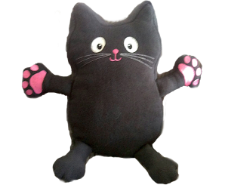](https://www.google.co.uk/url?sa=i&url=https://www.jigsawpshe.com/training/Additional-Jerrie-Cat-Friend-s-for-Ages-3-11-12-p140622057&psig=AOvVaw1AL9cs-uEjwSJkTKQc6grZ&ust=1585215628921000&source=images&cd=vfe&ved=0CAIQjRxqFwoTCLCwnb-qtegCFQAAAAAdAAAAABAD)Please look after my cat by …………….

You have to ask someone to look after your cat! Can you write a list of instructions to help them?

|  |  |  |  |
| --- | --- | --- | --- |
| Image result for water for a cat | https://www.petmd.com/sites/default/files/cat-is-happy-about-its-food-a-cat-licks-her-mouth-with-her-tongue-picture-id928162688.jpg | Image result for cat brush | Image result for cat flap |
| water | food | brush | cat flap |
| Image result for cat toys | Image result for cat bed | Image result for cat in the garden | Image result for cat at the vet |
| play | sleep | outside | vet |
| **How to look after my cat** | | | |
|  | | | |
|  | | | |
|  | | | |
|  | | | |
|  | | | |
|  | | | |
|  | | | |
|  | | | |
|  | | | |
|  | | | |
|  | | | |
|  | | | |
|  | | | |