Walter Infant School and Nursery
School Development Plan 2018 19
Target Review September 2019

Targets for School Development Plan 2018 2019

Effectiveness of Leadership and Management
To grow the leadership skills of all leaders in school to develop accountability and responsibility and to embed the work that has already begun.
- We have established a strong leadership team with a wide skills base. The Senior Leadership Team meets regularly and information is cascaded with all teams, where necessary.
- We have developed the roles of all subject leaders; each leader has an operational plan with SMART targets designed to meet the teaching and learning needs of the children

Quality of Teaching, Learning and Assessment

2.1 To increase the number of children at ARE (EXS and GDS) in Writing by the end of EOFKS1 81% to 85% (still 2% to go)
Year Two end of year results 2019 for ARE +
 | PPG | SEN | EAL | Boys | Girls | All children
Writing | 73% | 50% | 88% | 81% | 86% | 83%

2.2 100% of lessons observed are good or better
This target has been met.
2.3 To close the gaps in progress and attainment for identified groups in each cohort, including the gender gap in mathematics and writing
Each child has a value of 1.1%
Year Two end of year results 2016 for ARE +
 | PPG | SEN | EAL | Boys | Girls | All Children
Writing | 22% | 0% | 68% | 56% | 69% | 63%
Reading | 22% | 22% | 77% | 74% | 76% | 75%
Maths | 22% | 11% | 82% | 77% | 83% | 80%
Science | 44% | 11% | 82% | 79% | 87% | 83%
Year Two end of year results 2017 for ARE +
 | PPG | SEN | EAL | Boys | Girls | All children
Writing | 43% | 14% | 79% | 72% | 83% | 76%
Reading | 57% | 71% | 83% | 80% | 83% | 81%
Maths | 71% | 57% | 83% | 80% | 83% | 81%
Science | 57% | 43% | 79% | 80% | 86% | 82%
Year Two end of year results 2018 for ARE +
 | PPG | SEN | EAL | Boys | Girls | All children
Writing | 63% | 33% | 75% | 77% | 86% | 81%
Reading | 75% | 56% | 94% | 87% | 91% | 89%
Maths | 75% | 67% | 94% | 96% | 84% | 90%
Science | 100% | 89% | 100% | 100% | 98% | 99%
Year Two end of year results 2019 for ARE +
 | PPG | SEN | EAL | Boys | Girls | All children
Writing | 74% | 33% | 87% | 82% | 86% | 84%
Reading | 75% | 50% | 87% | 83% | 86% | 85%
Maths | 93% | 67% | 96% | 88% | 94% | 91%
Science | 100% | 100% | 100% | 100% | 100% | 100%

2.4 To embed our new BIG Curriculum for little people; to ensure a broad, rich and balanced curriculum for all our children with a focus on enquiry based skills and curriculum enhancement
This target has been met; please see the curriculum on the website

Personal Development, behaviour and Welfare

To embed our newly agreed school values across all aspects of Walter Infant School and the School Community
- Empathy
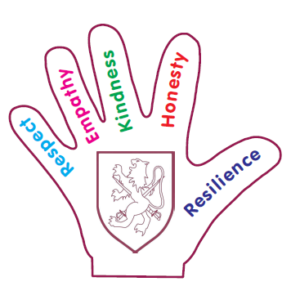
- Kindness
- Honesty
- Resilience
- Respect

This target has been met.

