Walter Infant School and Nursery
Murray Road Wokingham RG41 2TA
Tel: 0118 978 0825
www.walter.wokingham.sch.uk
admin@walter.wokingham.sch.uk
Headteacher: Mrs Judy Wheeler

Wednesday 2nd March 2022

Update for Walter Infant School and Nursery

Dear Parents and Carers,

We have made an adjustment to our guidance as a result of information shared in a Headteacher’s Briefing yesterday;

At Walter Infant School and Nursery, we will update our risk assessments and outbreak management plans to reflect the changes from the DfE. These are our updated procedures (see Rick Assessment on the website)
- We will continue to send children with symptoms home and request that parents and carers follow the expectations listed below: What to do if you have Covid 19
- Anyone feeling unwell (or has someone in their household) with COVID 19 symptoms will still be advised to have a PCR test and to follow DfE and School Guidance to stay at home until a negative test result is received. See table.
- No one to come to school if they have positive PCR result.
- If a household member tests positive – request that the staff member or pupil has an LFD test daily for 7 days available free of charge until 31st March 2022
- We recognise that ventilation is paramount. Windows must be open at all times
- The Site Controller will ensure that CO2 monitors in every class are checked and tested daily
- If necessary, we will provide PCR tests if required (from a limited bank of tests)
- Manage our Covid 19 register and follow the due dates for return to school
- Maintain high cleanliness measures to reduce the spread of the virus

You can still order LFD tests free of charge up until the 31st of March 2022.

We will no longer expect face coverings to be worn outside whilst on our premises but will respect the wishes of those who continue to do so. It has been so lovely seeing your faces!

We will resume whole school assemblies (which I am particularly looking forward to) including whole school singing.

We would like the children to continue to wear PE kits on the days they have PE lessons. We will also continue to line up outside in Key Stage 1 as this has allowed the children to all enter school together which we believe works best.

What to do if you have COVID-19
The most effective way to avoid passing on COVID-19 infection is to stay at home and avoid contact with other people.
When someone with COVID-19 breathes, speaks, coughs or sneezes, they release small particles (droplets and aerosols) that contain the virus that causes COVID-19. These particles can come into contact with the eyes, nose or mouth or can be breathed in by another person. The particles can also land on surfaces and be passed from person to person via touch.
The risk of catching or passing on COVID-19 can be higher in certain places and when doing certain activities such as singing or vigorous exercise. In general, the risk of catching or passing on COVID-19 is highest when you are physically close to someone who is infected.
However, it is possible to be infected even by someone you do not have close contact with, especially if you are in a crowded, enclosed or poorly ventilated space. This is because the infectious particles can stay suspended in the air for some time.
If you have COVID-19, stay at home and avoid contact with other people
If you have COVID-19 you can infect other people from 2 days before your symptoms start, and for up to 10 days after. You can pass on the infection to others, even if you have mild symptoms or no symptoms at all. If you have COVID-19 you should stay at home and avoid contact with other people.
You should:
- not attend work. If you are unable to work from home, you should talk to your employer about options available to you. You may be eligible for Statutory Sick Pay
- ask friends, family, neighbours or volunteers to get food and other essentials for you
- not invite social visitors into your home, including friends and family
- postpone all non-essential services and repairs that require a home visit
- cancel routine medical and dental appointments. If you are concerned about your health or you have been asked to attend an appointment in person during this time, discuss this with your medical contact and let them know about your symptoms or your test result
- if you can, let people who you have been in close contact with know about your positive test result so that they can follow this guidance
Many people will no longer be infectious to others after 5 days. You may choose to take an LFD test from 5 days after your symptoms started (or the day your test was taken if you did not have symptoms) followed by another LFD test the next day. If both these test results are negative, and you do not have a high temperature, the risk that you are still infectious is much lower and you can safely return to your normal routine.

How to safely return to your normal routine before 10 days
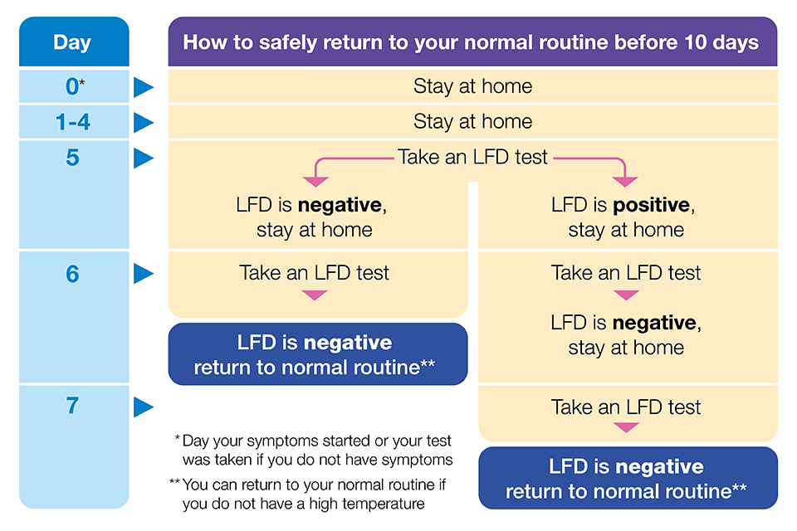
If your (your child’s) day 5 LFD test result is positive, you can continue taking LFD tests until you receive 2 consecutive negative test results.
Children and young people with COVID-19 should not attend their education setting while they are infectious. They should take an LFD test from 5 days after their symptoms started (or the day their test was taken if they did not have symptoms) followed by another one the next day. If both these test results are negative, they should return to their educational setting if they normally attend one, as long as they feel well enough to do so and do not have a temperature. They should follow the guidance for their educational setting.
If you have any questions, please do not hesitate to contact me directly on head@walter.wokingham.sch.uk
Thank you for you continued support and co-operation.
Yours sincerely
Judy Wheeler ~ Headteacher

