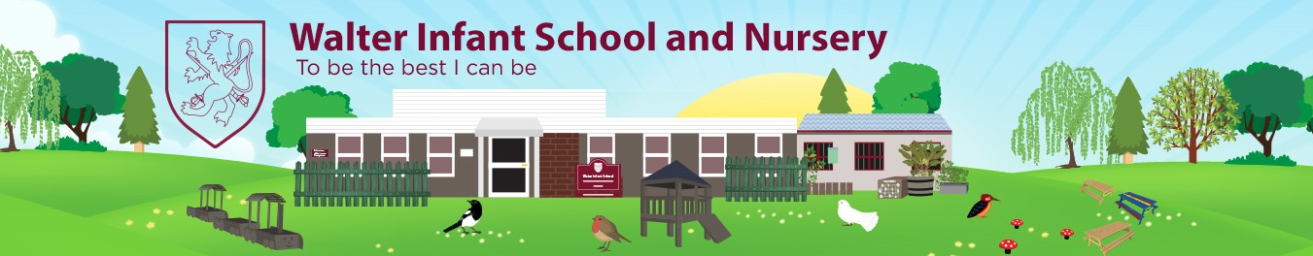
Foundation Stage 2 at Walter Infant School and Nursery
Information for Parents and Carers
Walter Infant School and Nursery is an equitable, safe, secure and happy place to learn; our children grow as individuals in a stimulating and exciting environment which values respect, empathy, kindness, honesty and resilience.
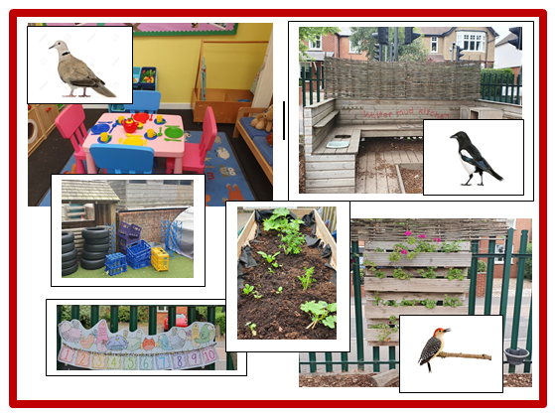
Walter Infant School and Nursery
Murray Road, Wokingham, RG41 2TA.
Tel: 0118 978 0825
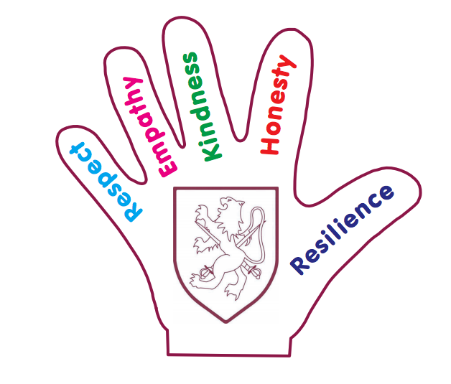

www.walter.wokingham.sch.uk
admin@walter.wokingham.sch.uk

Headteacher: Mrs Judy Wheeler

‘To Be the Best I Can Be’
Welcome to our new children and their families
Welcome to Walter Infant School and Nursery; I hope that this booklet will answer many of your questions. If you require any further information, please do not hesitate to contact Mrs Janes or Mrs Hemmings in the school office on admin@walter.wokingham.sch.uk at any time.
Mrs Jessica Bennette
Foundation Leader

Our Staff Team and Classes
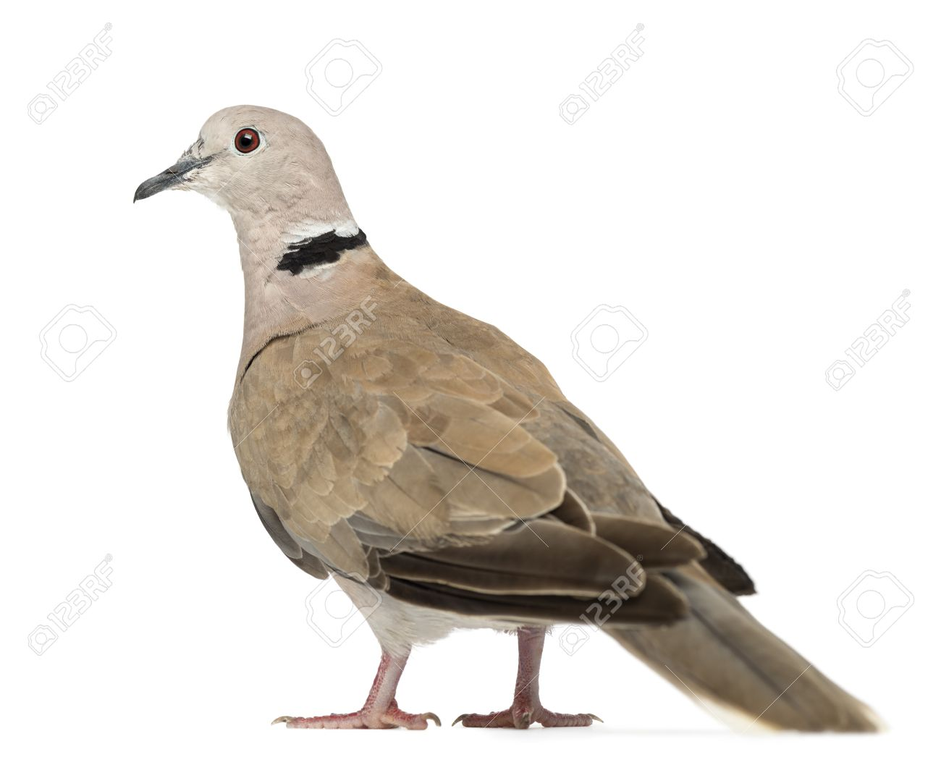  Dove | Class Teacher  Mrs Bennette | LSA  Mrs Althorp | LSA for FS2  Mrs Adams Price
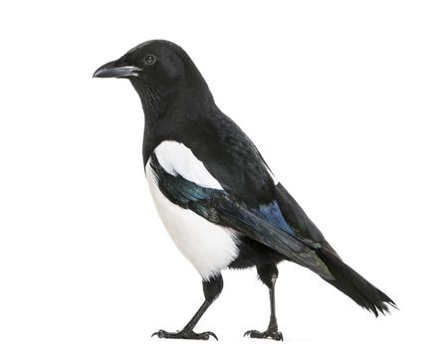  Magpie | Class Teacher  Miss Prickett | LSA  Mrs Lloyd
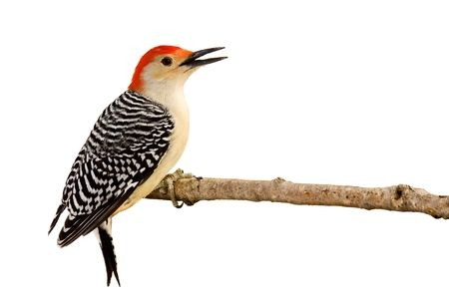  Woodpecker | Class Teacher  Miss Rose | LSA  Mrs Issa | 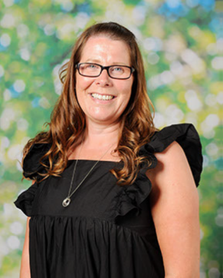  EYP  Ms Jacobs

Mrs Bennette leads our dedicated and talented team, who have exceptional experience of working with young children at the beginning of their school lives. They are all ready to welcome your children with open arms. They will ensure your child enjoys their time in school; they will enable all children to develop socially, physically and academically in a fun, exciting and stimulating environment following our ‘Big Curriculum for Little People’.
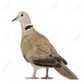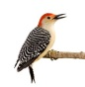
Day to Day Organisation
Foundation Stage 2 begins at 8:45 am; the children come into the playground in the morning and wait with their parents or carers until the class gates open; each gate has a picture of their class bird. Their teachers welcome them in and the gates close at 8:50 am. If you arrive after 8:50 am you will need to enter school through our reception area.

With help from our team, the children will hang up their coats on their own pegs and organise their belongings into their own drawer, all will be carefully labelled. They will place their water bottles in the trays provided for easy access throughout the day. We will take the register and lunch selections.

The children will have their lunch at 11:30 am until 12:30 pm. The children eat their lunches in the school hall, supervised by our wonderful team of lunch time controllers.

The children will go home at 3:15 pm; we ask that they are met at the same gate that they come in through. Each child will be released one at a time to an expected adult known to the school. We will only release the children into the care of responsible adults that routinely collect the children. We will not release the children to older siblings, unless they are an adult. If there are changes to the usual adult please contact the office before the end of the school day and the class teacher will be informed. You will need to share a password so that we know we can release the child. Please do not try to collect other people’s children for them if their parent or carer is running late. Please do not be offended if we refuse to hand over a child that does not belong to you.

Absence from School
If your child is unwell please email the school on absences@walter.wokingham.sch.uk or call the school as soon as possible on 01189 780825; you can leave a message and tell us why your child is absent. Please let your class teacher or the office know if your child needs to attend a medical appointment.
School Uniform
The children are expected to come to school in their school uniform. This is to help them feel part of our community and to keep the children looking smart and ready to learn. Our school uniform is as follows:
- Jogging bottoms, shorts or leggings in black, navy or dark grey or a school skirt or pinafore
- Navy/white/blue polo shirt
- Walter Infant School Jumper/Cardigan or a burgundy jumper
- Blue check school dress in the summer
- Trainers – no laces but any colour
- A coat with a hood
- Wellies: if you have a spare pair they come in very useful on wet, rainy days.
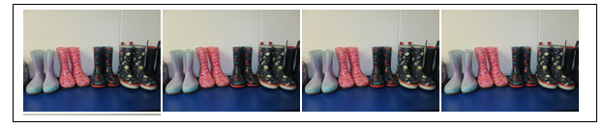
If you would like to order any of the school uniform please visit the following website. The website contains an up-to-date price list and is sorted by year groups for easy ordering: http://walter.gooddies.co.uk/
Please ensure that ALL clothing is named to minimise a risk of loss, including trainers
It is a good idea for your child has a spare set of clothes in school, which can be in a bag left on their peg, just in case!
Food and Drink
Water
The children need to bring in a named water bottle, which stays in their classroom which they can access throughout the day. Filled with water only please.
Snacks
We provide a piece of fruit or a vegetable for every child daily. Please do not send in other snacks.
Milk
Every child is entitled to a free carton of milk until they are 5. Please register for your child to receive milk.
registration@coolmilk.com
www.coolmilk.com or call 0844 854 2913
Alternatively, please contact the school office for a ‘Cool Milk’ form.

Packed Lunches
Please ensure that if you are packing a lunch for lunch club, that you include food your child enjoys eating. They will need to be able to feed themselves although we will help with opening packets. Please do not include any sweets or nuts. We recommend food that should be eaten cold; we do not have facilities to warm food up. We would usually expect to see a salad or pasta dish, or a sandwich, roll or wrap with a filling that your child enjoys, a piece of fruit or vegetables, yoghurts or cheese and maybe a sweet or savoury snack such as a cake, biscuit, crisps or crackers.
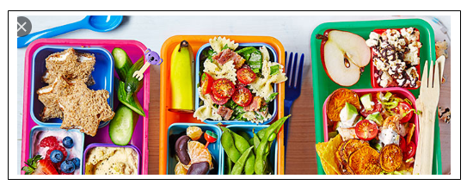
Allergies/Dietary Requirements
It is very important for us to know about any allergies or food intolerances when your child starts school. We are a no nuts school; Please do not bring anything to school containing nuts. If you have any concerns please speak with your class teacher.
Our Learning Environment
Our children learn inside and outside in our wonderful classroom and garden; 80% of their time is child initiated and 20% is adult led. We work hard to get the balance right and we plan every activity and learning opportunity to meet the children’s learning needs. They also have access to continuous provision where they meet their own learning needs in every element of the Early Years Curriculum. The children will learn from real life experiences or excellent quality fiction and non-fiction texts.
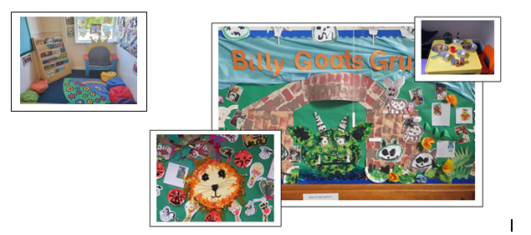
The Outside Environment
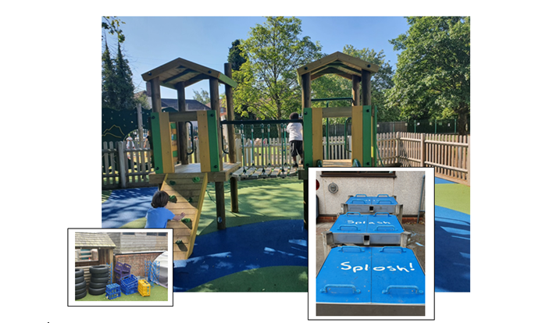
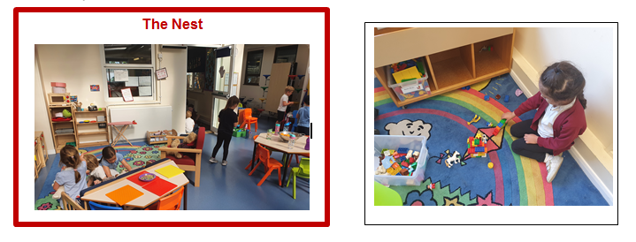

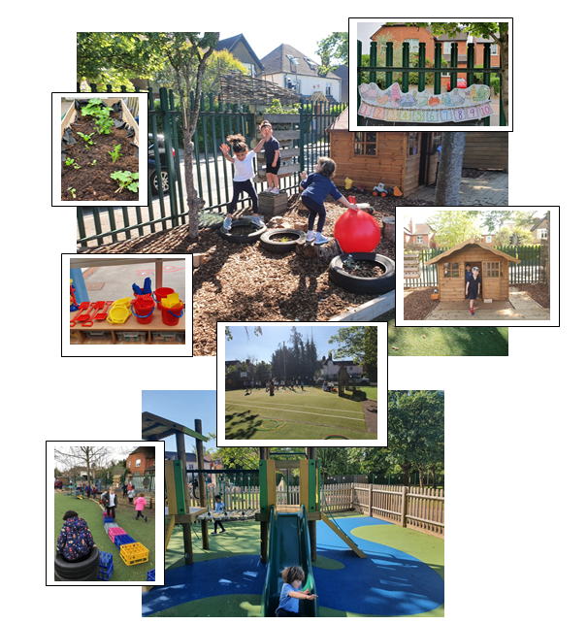

Parent Partnerships
We usually offer every family a home visit before a child starts with us; unfortunately we are unable to do this at this time. We understand that the children’s families are the experts about their children and we want to be well-prepared when the child starts school so that we can make the transition as smooth as possible. We have therefore included a questionnaire to enable you to share information with us that will help us to get to know your child more quickly.
We have an ‘Open Door Policy’ at Walter Infant School and Nursery and staff members are available at the beginning or end of the session. If you need a longer appointment you will be able to organise it directly with the teacher or with the admin teams.
We would like to work in partnership with you to make sure that we give your child the best start to their education. We are available to speak with at drop off or pick up times. Please come and talk to us about your child, let us know if there is anything we should know or if anything changes. Throughout the year there will be times to meet more formally at parent consultations and also times to come in and play with your child.
Health and Well-being

Our staff team are qualified paediatric first aiders; we will administer first aid if your child needs it during the school day. You will be informed if your child has an accident such as a cut or a graze via our first aid reporting system.

If your child receives a bump to the head, you will be contacted by telephone, as it is our policy to inform parents because of the risk of concussion or compression.

It is imperative that your contact details are kept up to date.

If a child has an accident that we suspect could be a broken limb, the parent is informed immediately. If necessary we will call an ambulance and inform you of its destination.

Illness
Childhood illnesses are common; if your child has sickness or diarrhoea please keep them away from school for 48hours after their last episode. If you have a concern about whether your child should be in school, please telephone the office and we will be able to advise you.

Our Big Curriculum for Little People: The Early Learning Goals

We have designed a ‘BIG’ curriculum to excite, inspire and foster a desire to learn; we want our children to know more about the world around them and to be happy, confident and successful.

We want our children to have very positive behaviours for learning and to ask BIG questions and we want our staff team to support our children in finding authentic, age-appropriate answers to questions which stimulate them to want to learn more.

The children will learn through real-life and practical experiences, as well as through wonderful, awe inspiring fiction texts and exciting non-fiction texts. Our children will learn inside and outside the classroom, fulfilling and exceeding the requirements of national Early Years Curriculum and Early Learning Goals in a stimulating and memorable way.
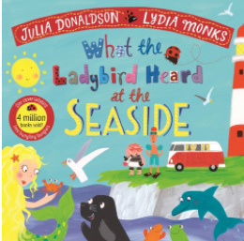
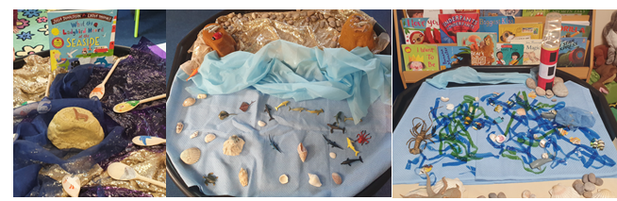

The Early Learning Goals 2021

Communication and Language | Listening, Attention and Understanding ELG  Children at the expected level of development will:  - Listen attentively and respond to what they hear with relevant questions, comments and actions when being read to and during whole class discussions and small group interactions;  - Make comments about what they have heard and ask questions to clarify their understanding;  - Hold conversations when engaged in back-and-forth exchanges with their teacher and peers
Speaking ELG
Children at the expected level of development will:
- Participate in small group, class and one to one discussions, offering their own ideas, using recently introduced vocabulary;
- Offer explanations for why things might happen, making use of recently introduced vocabulary from stories, non-fiction, rhymes and poems when appropriate;
- Express their ideas and feelings about their experiences using full sentences, including use of past, present and future tenses and making use of conjunctions, with modelling and support from their teacher.
Personal, Social and Emotional Development | Self-Regulation ELG  Children at the expected level of development will:  - Show an understanding of their own feelings and those of others, and begin to regulate their behaviour accordingly  - Set and work towards simple goals, being able to wait for what they want and control their immediate impulses when appropriate;  - Give focused attention to what the teacher says, responding appropriately even when engaged in an activity, and show an ability to follow instructions involving several ideas or actions
Managing Self ELG
Children at the expected level of development will:
- Be confident to try new activities and show independence, resilience and perseverance in the face of challenge;
- Explain the reasons for rules, know right from wrong and try to behave accordingly;
- Manage their own basic hygiene and personal needs, including dressing, going to the toilet and understanding the importance of healthy food choices.
Building Relationships ELG
Children at the expected level of development will:
- Work and play cooperatively and take turns with others;
- Form positive attachments to adults and friendships with peers;
- Show sensitivity to their own and others’ needs.
Physical Development | Gross Motor Skills ELG  Children at the expected level of development will:  - Negotiate space and obstacles safely, with consideration for themselves and others;  - Demonstrate strength, balance and co-ordination when playing;  - Move energetically, such as running. Jumping, dancing, hopping, skipping and climbing.
Fine Motor Skills ELG
Children at the expected level of development will:
- Hold a pencil effectively in preparation for fluent writing – using a tripod grip in almost all cases;
- Use a range of small tools, including scissors, paint brushes and cutlery;
- Begin to show accuracy and care when drawing
Literacy | Comprehension ELG  Children at the expected level of development will:  - Demonstrate understanding of what has been read to them by retelling stories and narratives using their own words and recently introduced vocabulary;  - Anticipate – where appropriate – key events in stories;  - Use and understand recently introduced vocabulary during discussions about stories, non-fiction, rhymes and during role play.
Word Reading ELG
Children at the expected level of development will:
- Say a sound for each letter in the alphabet and at least 10 digraphs;
- Read words consistent with their phonic knowledge by sound blending;
- Read aloud simple sentences and books that are consistent with the phonic knowledge, including some common exception words.
Writing
Children at the expected level of development will:
- Write recognisable letters, most of which are correctly formed;
- Spell words by identifying sounds in them and representing the sounds with a letter or letters;
- Write simple phrases and sentences that can be read by others.
Mathematics | Number ELG  Children at the expected level of development will:  - Have a deep understanding of number to 10, including the composition of each number;  - Subitise (recognise quantities without counting) up to 5;  - Automatically recall (without reference to rhymes, counting or other aids) number bonds up to 5 (including subtraction facts) and some number bonds to 10, including double facts.
Numerical Patterns ELG
Children at the expected level of development will:
- Verbally count beyond 20, recognising the pattern of the counting system;
- Compare quantities up to 10 in different contexts, recognising when one quantity is greater than, less than or the same as the other quantity;
- Explore and represent patterns within numbers up to 10, including evens and odds, double facts and how quantities can be distributed equally.
Understanding the World | Past and Present ELG  Children at the expected level of development will:  - Talk about the lives of the people around them and their roles in society;  - Know some similarities and differences between things in the past and now, drawing on their experiences and what has been read in class;  - Understand the past through settings, characters and events encountered in books read in class and story telling.
People Culture and Communities ELG
Children at the expected level of development will:
- Describe their immediate environment using knowledge from observation, discussion, stories, non-fiction texts and maps;
- Know some similarities and differences between different religious and cultural communities in this country, drawing on their experiences and what has been read in class;
- Explain some similarities and differences between life in this country and life in other countries, drawing on knowledge from stories, non-fiction texts and – when appropriate – maps.
The Natural World ELG
Children at the expected level of development will:
- Explore the natural world around them, making observations and drawing pictures of animals and plants;
- Know some similarities and differences between the natural world round them and contrasting environments, drawing on their experiences and what has been read in class;
- Understand some important processes and changes in the natural world around them, including the seasons and changing states of matter.
Expressive Arts and Design | Expressive Arts and Design Creating with Materials ELG  Children at the expected level of development will:  - Safely use and explore a variety of materials, tools and techniques, experimenting with colour, design, texture, form and function;  - Share their creations, explaining the process they have used;  - Make use of props and materials when role playing characters in narratives and stories.
Being Imaginative and Expressive ELG
Children at the expected level of development will:
- Invent, adapt and recount narratives and stories with peers and their teacher;
- Sing a range of well-known nursery rhymes and songs; - Perform songs, rhymes, poems and stories with others, and – when appropriate try to move in time with music

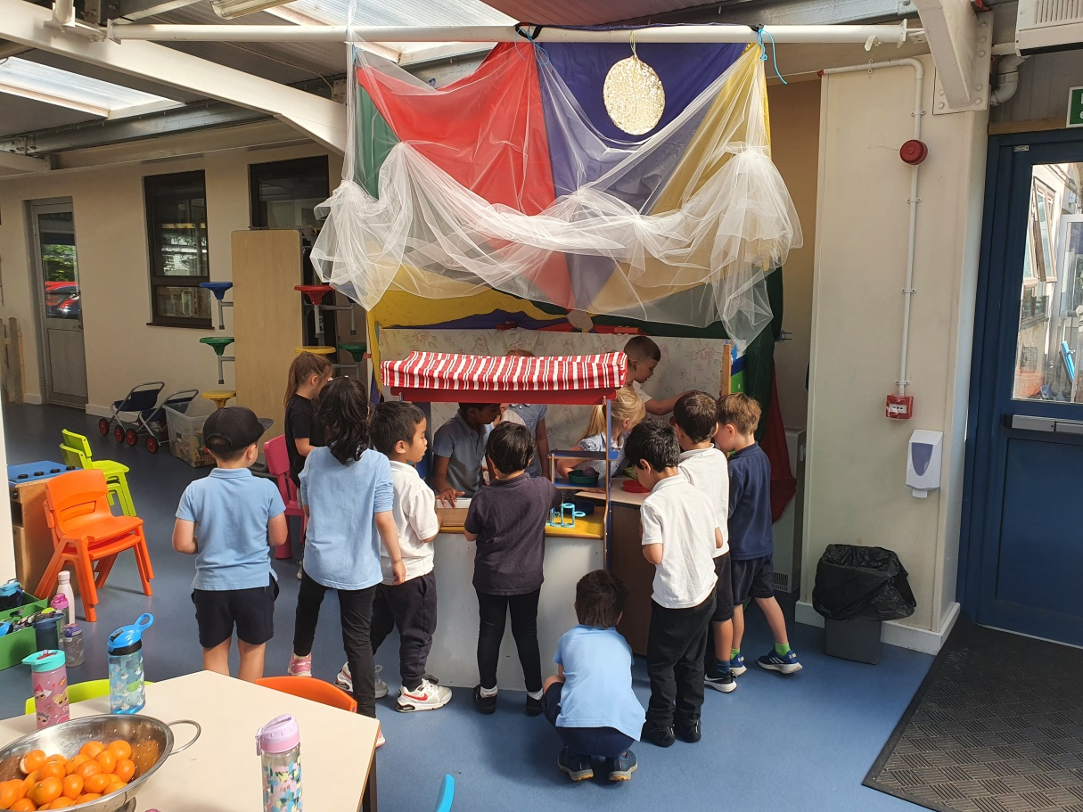

Characteristics for Learning

Children learn in different ways; our learning environment is designed to ensure that at all children can learn and develop a love for learning and a desire to know more: The characteristics of learning help us to see when children are learning; they tell us that children are learning when they are:
- Engaged
- Motivated
- Thinking
In planning and guiding children’s activities, our teachers and practitioners reflect on the different ways that children learn and provide for these in our practice. Three characteristics of effective teaching and learning are:
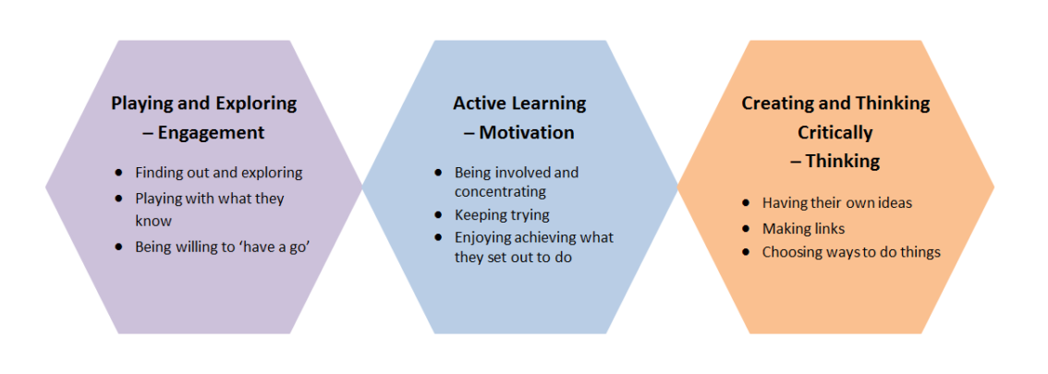
Phonics in Foundation Stage

In the Foundation Stage we provide an environment designed to develop the language, listening and literacy skills needed to enable your child to become a confident communicator. An integral part of this provision is a daily phonics session. The sessions last for approximately fifteen minutes in F2 and all children take part in activities tailored to their stage of development.

Phase 1: Our children are taught to listen for sounds around them; environmental sounds, music, body percussion such as clapping etc. We have a bank of 20 core rhymes that we share with all our families so that they can learn alongside. Phase 1 phonics also encourages the children to explore language: listening for sounds in words, alliteration, rhythm and rhyme and to learn a variety of different ways of making sounds. There is a strong focus on listening skills so children in Foundation learn a range of songs and rhymes relating to our topics, such as Christmas songs as an enjoyable means to develop their auditory memory.

Phase 2: We introduce individual sounds (phonemes) alongside Common Exception Words (such as I, the, to, no) in the order set out in the Letters and Sounds scheme. This promotes
“phonemic awareness” (the point at which children realise that you can take a word apart and put it back together again (eg /d/o/g/ = dog). Common Exception Words are those words which are needed for early reading and writing but which follow phonic rules that have not yet been taught.

Once children can hear, say and remember a range of phonemes (s,a,t,p,i,n,m,d) they can begin to blend them to read simple words and segment words into sounds in order to spell them. It is very important when teaching the articulation of phonemes that the sound is pure (ss not suh and mm not muh) to enable blending. Following on from the teaching of single letter phonemes, we introduce a range of digraphs and trigraphs (2 or 3 letters making one sound that cannot be broken down into smaller sounds: eg ch,th,sh,ng,ai,ee,igh,oa,oo). This ensures that children are equipped with at least one possible spelling for all of the sounds we use in English.

The emphasis is on phonic sessions which are quick, engaging and fun. We use an online resource called Phonics Play, which includes phonic games to help children read and distinguish between real and nonsense words as well as consolidating a range of other skills. A free version of Phonics Play is available to access at home (www.phonicsplay.co.uk)

We will present a session on How We Teach Phonics in the Foundation Stage in the autumn term. This is aimed at helping parents and carers to support their children at home.

Pupil Premium Funding
Does your child qualify for Pupil Premium Funding?

Pupil Premium funding is an additional amount of funding allocated to schools by the government to support the learning and progress of children in receipt of free school meals or those looked after by the local authority. It is for schools to decide how the Pupil Premium Funding is spent and we are held accountable for the impact the funding has on those for whom the money is allocated.

All children in FS2, Year 1 and Year2 are entitled to a Universal Free School meal; however, we may be able to access additional funding to support your child and other children access the curriculum or indeed extra-curricular activities.

Children who are or have been in care, and children who have a parent who is or was in the armed forces, are also entitled to pupil premium.

If you are in receipt of:
- Universal credit (provided you have a net income of £7400 or less)
- Income support
- Income-based jobseekers’ allowance
- Income-related employment and support allowance
- Support under Part IV of the Immigration and Asylum Act 1999
- The guaranteed element of state pension credit
- Child tax credit, provided that you are not also entitled to working tax credit and have an annual gross income of £16,190 or less.

We have included an application form in our pack for you to complete if you think you may be eligible; the funding will benefit your child and other children in our school.

We use the funding to support our children in a wide variety of ways:
- Access to extra-curricular activities in school such as a sports club
- Help with school uniform
- Canine Assisted Learning from our therapy dogs Walter & Charlie
- Help towards the cost of school trips
- Additional resources for differentiated learning
- Pupil Premium Champions; members of staff who works with the teachers to find the best way to identify barriers to learning and close gaps.

Walter Infant School and Nursery
Safeguarding Policy & Procedures
We are committed to safeguarding children and have a duty to refer any
suspected cases of neglect or harm to the appropriate agencies.
The Role of the Designated Person for Safeguarding  - Listen and act when adults report concerns  - To make referrals to Social Care if necessary  - Ensure confidential records are kept  - Attend case conferences and provide reports  - Ensure all staff are aware of school’s Safeguarding Policy and procedures  - Ensure unexplained absences are referred to the Education Welfare Officer  - Keep themselves up to date with knowledge to enable them to fulfil their role and attend training every two years  - Provide an anonymised report to the Governors once a term  - Notify Social Care when a child is privately fostered  - Ensure that any concerns about a pupil who leaves the school are forwarded to the next school. | The Safeguarding Children Team at Walter Infant School  Designated Person for Safeguarding is the Head Teacher, Judy Wheeler 0118 978 0825. Deputy Designated Person for Safeguarding is the Deputy Head Teacher, Fiona Prickett. The Inclusion Manager is Louise Walker.  Your Safeguarding Children Team also links with the Nominated Governor for Safeguarding: Charlotte Kirkaldy
The welfare of the child is our paramount concern. If you are concerned, report your concerns to the Designated Person for Safeguarding — Judy Wheeler
or Chair of Governors – Ghislene Lokuciewski
0118 978 0825
 | For a copy of our full Safeguarding Policy please go to www.walter.wokingham.sch.uk or ask at the School Office

Term Dates 2021-2021
Autumn Term 2021
Inset Day – School Closed Wednesday 1st September
Start of Term (Year 1 & 2 only) Thursday 2nd September
Half Term 25th October to 29th October
End of Term Friday 17th December – finishing 1 hour early

Spring Term 2022
Inset Day – School Closed Tuesday 4th January
Start of Term Wednesday 5th January
Half Term 21st February to 25th February
End of Term Thursday 7th April – finishing 1 hour early
Inset Day – School Closed Friday 8th April

Summer Term 2022
Start of Term Monday 25th April
Bank Holiday – School Closed Monday 2nd May
Half Term 30th May to 3rdJune
Inset Day – School Closed Monday 6th June
End of Term Wednesday 20th July – finishing 1 hour early
Inset Day – School Closed Thursday 21st July

