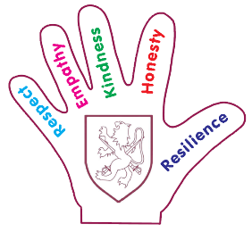
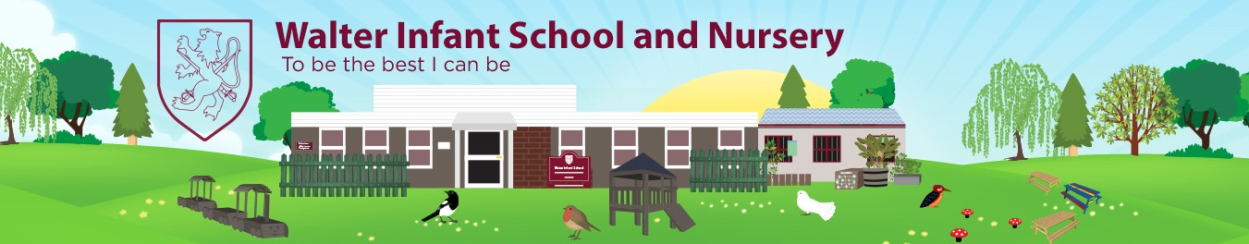
Foundation 2 - Spring Two Curriculum Intent
Food
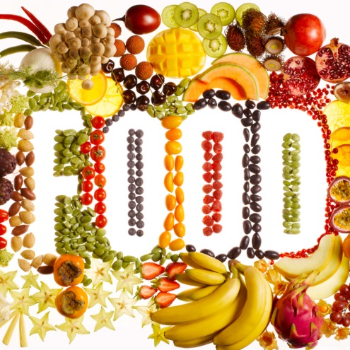
Walter Values
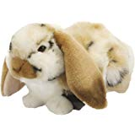  Respect | Respecting others when talking about the different foods we eat in different cultures and our favourite food.
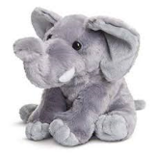  Empathy | Showing empathy when thinking about foods we like to eat and foods we might not be able to eat.
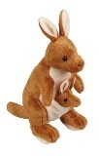  Kindness | Being kind to ourselves by keeping our bodies healthy.
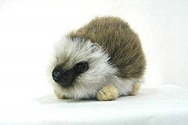  Honesty | Sharing our favourite foods and remembering it’s ok to have different favourite foods to our friends.
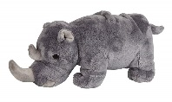  Resilience | Demonstrating resilience when using tools to prepare food and when trying new foods.

Area of Learning Key
Literacy | Maths | RE | PSED
Understanding  the World | Physical Development | Communication  and Language | Expressive Arts  & Design

Subject Concepts

Subject Connectors
Subject | Connector
 | As enquirers we are investigating different foods and where they come from.
 | As designers we are preparing healthy foods.
 | As scientists, we are learning about keeping ourselves healthy and clean.
 | As enquirers we are learning about the Christian festival of Easter and how it is celebrated.
 | As scientists we are finding out how food is grown.
 | As artists we are exploring the work of great artists and being inspired to create our own artwork.

Intended Activities, Tasks and Knowledge
Activity/Task/Knowledge | Curriculum Coverage
To prepare and taste healthy foods.
To find out where food comes from and learn how foods grow.
To learn about Guiseppe Arcimboldo’s paintings, creating own portraits in the same style.
To learn about Shrove Tuesday and the Christian festival of Easter.
To participate in yoga sessions.

PD – Multi skills
Activities, games and practices that are designed to challenge participants to learn a range of different skills and techniques.

PSHE and RE
Jigsaw PSHE | Discovery RE
Healthy Me  Healthy Body and Mind  Keeping Clean  Healthy Eating  Stranger Danger | Christianity – Easter  What is Easter?  How Easter is celebrated.

Intended Additional Literacy Coverage
The Runaway Pancake
Exploring stories that are similar
Retelling stories and innovating
Writing simple sentences
Supertato
Writing labels/captions to describe story characters
Write simple sentences about the story
Handa’s Surprise
Sequence the story
Create story maps
Use story map to write simple sentences about the story

Intended Additional Mathematics Coverage
Number
Finding one more or one less from a group of up to five objects, then ten objects
Number recognition
Ordering numbers to twenty
Shape, space and measure
Selects a particular named shape
Ordering objects by weight (heaviest/lightest)
Ordering and comparing height

