Dear Walter Families,

I am delighted to say that Father Christmas has been in touch with me again this year to say that it will be business as usual in his workshop and the sooner he gets to know what you are hoping to receive for Christmas the better!

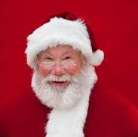
“Ho Ho Ho! I am so excited to say that my elves and I are ready for the Christmas Rush! We can’t wait until Christmas Eve to start delivering presents to boys and girls all over the world, using Christmas magic, of course! So… we need to know what you would like so I am inviting you to send me a letter, via Elf Mail. My elves will collect all your letters and I will write back to each and every one of you and include a special treat” ~ Father Christmas

If you would like to write to Father Christmas; please use the template attached. Postage to the North Pole is rather expensive as it is so far away; please enclose £3 in the envelope and post it in the post box at school from the week beginning Monday 6th December 2021. The last day for post is Friday 10th December 2021.

If younger or older siblings would also like to send a letter, please download the template from the website and print off as many copies as you want! Please remember to make sure that you record a first name and surname as well as the class of the child that comes to our school!

Here is a magical bar code and a special key for all those of you who do not have a chimney. Stick the code and the key to the outside of the front door on Christmas Eve. Father Christmas will be able to scan the code to get in to deliver the presents!

Best wishes and Seasons Greetings
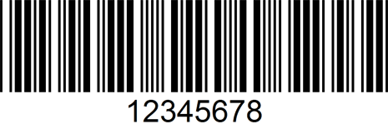
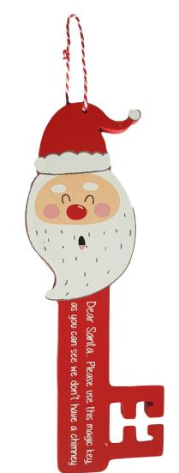

Judy Wheeler
Headteacher
