Walter Infant School and Nursery
Targets and Responsibilities from the School Development Plan 2021 2022

Covid 19 Pandemic
- To be a safe and healthy environment in which our children can thrive amidst the regulations and precautions in place for COVID 19 so that those risks and risk management become ‘Business as Usual’ for Walter Infant School and Nursery ~ Judy Wheeler

Quality of Education
- To complete the Reception Baseline Assessments in EYFS2
- To embed the Early Years Foundation Stage Guidance in our everyday practice and to adapt all documentation in line with the reformed Early Learning Goals ~ Jessica Bennette
- Catch Up: All children have the opportunity to access catch up resources and funding opportunities where identified ~ Judy Wheeler
Behaviours and Attitudes
- To enable our children to continue to regulate their own behaviour by following our Walter Values ~ Judy Wheeler & SLT
- To develop a metacognitive approach to learning for children and adults in school ~ Judy Wheeler and SLT

Personal Development
- To embed our agreed targets for Cultural Capital ~ Judy Wheeler & SLT

Leadership and Management
- To ensure leaders within school including governors are aware of the key changes to the OFSTED Inspection Framework ~ SLT
- All leaders in school ensure that good mental health is paramount for children and adults ~ Stephanie Rees
- All adults will have completed On Line Safety Training and read the new Online Safety Policy 2021 ~ Designated Safeguarding Leads and Anita Pugh

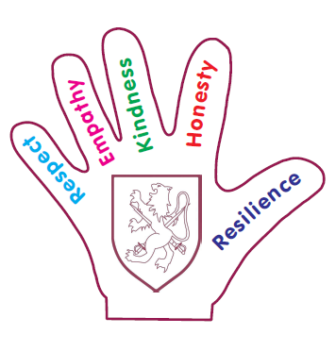
‘To be the best I can be’

