

Walter Infant School and Nursery

‘To be the best I can be’

ENGLISH POLICY

Version | Action | By | Date
1 | Approved | Full Governing Body | 2nd February 2017
1.1 | Approved | Full Governing Body | 4th July 2019

Responsibility of: Full Governing Body and the Headteacher
Date of Review: Summer Term 2021

List of Contents Page No

- Policy Statement and Aims 3
- Reading at Walter Infant School 3
2.1 Synthetic Phonics 3
2.2 Book Banding 4
2.3 Guided Reading 4
2.4 Other Reading and the Promotion of Books and Texts 5
3. Writing at Walter Infant School 5
3.1 Planning for Teaching and Writing in Key Stage 1 6
3.2 Writing at Foundation Stage 7
4. Cross Curricular Writing Opportunities 7
5. Speaking and Listening at Walter Infant School 8
6. Assessment and Personalised Learning 8
7. Inclusion 9
8. Equal Opportunities 9
9. Role of Subject Leader 9

Appendix A Simple View of Reading 11
Appendix B Phonics Phases from Letters and Sounds 12
Appendix C Book Band Colours 13
Appendix D Bloom’s Taxonomy 14

- POLICY STATEMENT AND AIMS

Our Walter Infant School and Nursery Policy is in line with the 2014 National Curriculum This policy is a statement of the school’s agreed approach to the teaching of the English Curriculum. It is to inform teachers, support staff, governors, parents/carers and the school community.

At Walter Infant School and Nursery by the end of Year 2, or Key Stage 1, our aim is for our children to be ‘Junior School Ready’. We want our children to leave Walter Infant School being able to write with fluency and accuracy at Age Related Expectations (ARE). We believe that we equip them with the foundations for lifelong reading and writing. For this reason, it is essential that the children receive the highest quality teaching for reading and writing possible. Best practice approaches have been adopted by the school to facilitate Quality First Teaching (QFT). This policy outlines the teaching of English at Walter Infant School and Nursery. Our school’s motto is ‘To be the best I can be’, and for this reason we want our children to leave our school being the best possible reader and writer.

- READING AT WALTER INFANT SCHOOL AND NURSERY

The National Curriculum states that children should be able to read fluently, and be encouraged to read for pleasure. Therefore, Walter Infant School and Nursery staff will do everything possible to promote an enjoyment and passion for reading. The children should have access to a wide variety and range of books, which includes fiction, non-fiction/information text and poetry.

The Simple View of Reading (Appendix A) and the current National Curriculum breaks reading down into two dimensions: word reading (or decoding) and language comprehension. Therefore, it is essential that children develop both these skills to enable them to become confident and able readers. Word reading is primarily taught through the teaching of synthetic phonics, and exposure to a wide range of vocabulary. Language Comprehension is developed through high quality book talk and discussion with an adult or teacher. Both skills require a broad access and exposure to high quality texts, which includes stories, non-fiction/information texts and poems

2.1 Synthetic Phonics

For children to be able to read they initially have to be taught how to decode, or turn print into meaning. This is done through exposure to a wide range of vocabulary, written and spoken. We also teach children synthetic phonics. Synthetic phonics is the process of breaking words down into their smallest possible sound. Much research has been done into the use of phonics as a decoding strategy, which has shown that it gives most children the best possible chance at reading or decoding words. Phonics should be used as the prime method; however, it is not the exclusive method for word reading. Other cueing strategies could be considered, such as word recognition or on-sight graphic knowledge (the shape a word makes), grammatical awareness (syntactic), or contextual understanding (semantic).

Phonics is taught daily at Walter Infant School and Nursery, and applied and promoted holistically across the school as the prime method for decoding (reading) or encoding (spelling) words. We use the Letters and Sound documentation as our primary scheme of work, which is supplemented by Jolly Phonics and the www.phonicsplay.co.uk website. Letters and Sounds separate phonics into six phases of teaching (Appendix B). Each phase is progressive, and consolidated through revision. Although teachers have the freedom to use whatever resources or schemas they wish, the www.phonicsplay.co.uk website is advocated as the primary method for planning and teaching groups of children phonics.

2.2 Book Banding

The book banding system is a universally adopted approach used by many schools to grade, or level books. The book bands are broken up into colour groups (Appendix C). The system was designed to allow teachers to choose the right texts at the right time when teaching children various skills required for reading. It is a way to organise books into a simple, progressive and useable system. Each book band, or colour, has a set of descriptors to differentiate each band and make the teaching of reading a systematic approach. These were expanded to include a wider range of colour bands. The school has also agreed and adopted a ‘Walter Level’ for reading. This was designed to allow the teachers to make better judgements when deciding on summative assessments on reading, and to encourage aspirational goals and targets.

2.3 Guided Reading

Guided Reading has been identified as a good model for teaching children to read. It allows for an environment whereby the children can practise and apply their phonics, or word reading skills, and allows for high quality discussions with a class teacher or supporting adult. The children should have at least one Guided Reading session a week, and this should be complemented with other activities that involve reading or the application of phonics.

Guided Reading allows children to explore a wide range of texts and discuss these to help develop an understanding. Children are taught in small groups of no more than six and the session is led by the teacher or learning support assistant. It is planned for using the objectives and programmes of study taken from the National Curriculum. Each session should last for approximately 20 minutes, be objective led, allow children opportunities to decode and consist of high quality discussions revolving around the chosen text. The enabling adult should act as a facilitator, by asking high quality questions and raising points for discussion by the children before, during and after reading. During this process the adult will take notes, which allows for a build-up of comments and evidence of the children’s reading ability and development of skills. The children then have an opportunity to return to the text and complete an activity to demonstrate their understanding and allow them to apply their skills.
Guided Reading starts in the Foundation Stage. The children are exposed to various texts and understand that books provide information, as well as stories and entertainment. Books are shared with the children on a regular basis (several times a day). They should be able to listen with increasing attention and join in with rhyming patterns and phrases. By the end of Foundation 2 the children should be able to: handle books independently, read from left to right, read short sentences whilst tracking with their fingers and start to discuss books; which includes making very simple predictions.

2.4 Other Reading and the Promotion of Books and Texts

The children have access to high quality texts. These are provided by our school library, which the children visit weekly, and the inclusion of a Reading Corner in each classroom. Books and texts should always be on display and celebrated around the school.

The children should be exposed to high quality texts on a daily basis. This is done through timetabled reading times, assemblies and through using texts as an inspiration for their writing. Whilst reading books and texts the teacher or adult should discuss what they are reading to ensure a good level of understanding and exposure to new vocabulary.

Books should be celebrated and shared to help children foster a love and enjoyment of reading. This is done through the sharing of books with the children and modelling positive attitudes towards reading and books. The school also takes part in such events as World Book Day, and holds book fairs wherever possible.

- WRITING AT WALTER INFANT SCHOOL AND NURSERY

The National Curriculum states that children should develop to become competent and fluent writers. The National Curriculum breaks the teaching of English into dimensions: transcription (spelling and handwriting); and composition (articulating ideas and structuring them from speech into writing). In order for children to become fluent and competent writers they need both of these areas to be well developed by the time they leave Walter Infant School and Nursery and be ‘Junior School Ready’.

The current National Curriculum has a greater focus on the grammar side of writing and requires a deeper understanding of the composition of a sentence. Handwriting is now promoted as a lifelong skill and has a greater emphasis towards developing fluency and accuracy of writing. As well as using phonics for encoding (spelling), the children are also required to have a well-developed understanding of various spelling patterns and rules, including adding various prefixes and suffixes.

Due to the heavier focus on the secretarial skills and requirements of the current National Curriculum, it is even more important to foster a creative and exciting learning environment for the children. This can be achieved through a use of high-quality texts, and resources to help inspire the children’s writing across the school.

3.1 Planning and Teaching for Writing in Key Stage 1

The teacher plans all writing opportunities or English lessons in line with the National Curriculum. The National Curriculum breaks down the Programmes of Study into four sections: Transcription, Composition, Vocabulary, Grammar & Punctuation and Handwriting. Each year group (Year 1 and 2), have their own separate objectives or outcomes. To meet the demands of fluency and accuracy with writing the children should only be taught using the Programmes of Study for their year group. The teacher should not go beyond these objectives, but rather teach at breadth to allow for mastery of these objectives in a variety of contexts, text types and genres.

Planning should be done through a personalised learning approach, as this is deemed best practice. The teachers should plan each unit to last for two weeks. The teacher first identifies, through formal and informal assessment, the greatest need for the children. This should be done by looking through the children’s books, through discussion and by employing a range of AfL strategies (Assessment for Learning). The teacher will then decide the next steps for the children’s learning. The main focus or outcomes are chosen from the National Curriculum for that year group. The teacher will choose one Programme of Study from a specific area to become the main focus for the unit of work. A Programme of Study is chosen from each area of the curriculum that links to the chosen outcomes of the unit. This will allow a good range and breadth of study. Outcomes, genres, text types and contexts are then chosen to support and drive the learning. Although, the genres, text types and contexts are not explicitly listed in the National Curriculum it is important that a good breadth is covered.
Once the unit plan has been created the teacher can then plan day-to-day. This should also follow a personalised learning approach. Daily planning should be based on the prior lesson’s learning, areas of development identified through Assessment for Learning (AfL) and the work the children have produced. The lesson should be objective led, by choosing or composing an intended learning objective based on the Programmes of Study. The learning objective should be context free, so that it is not constrained and it is measurable, for example, ‘I can use adjectives to describe a noun.’ rather than ‘I can write a poem using wow words’. An appropriate activity should then be planned for, which should be differentiated according to the ability of the children to enable all learners the best possible chance to achieve the objective. Success Criteria should be used to help children identify the steps for the learning, so they have a greater chance at being successful. The adults in the class should be used to guide children in small group work during the lesson. All children should have a guided session at least once a week. Pupils with specific needs, and in specifically identified vulnerable groups, should receive appropriate support, these could include SEN, Pupil Premium, EAL and various targeted groups.

To enable parity across all classes the respective year groups should plan as a team. For example, Year 2 plan a unit together for the following week. The objectives, outcomes and learning intentions are the same. The activities and resources can be created and shared across the year group. This should help to provide a good work load balance. The teacher should then plan for their own pupil’s needs and requirements.

3.2 Writing in the Foundation Stage

Early literacy skills are highly valued at Walter Infant School and Nursery; we celebrate all mark making and children are encouraged to publish and display their own work. There are many opportunities for children to write inside and outside each day; the children also work regularly in small adult-directed groups to develop their writing skills at an age appropriate level, with highly trained staff. They quickly become confident at encoding due to the systematic teaching of phonics. They are encouraged to take risks and share their thoughts and ideas using a variety of different equipment, media and tools.

The children are taught in shared and guided writing sessions; they are encouraged to write for different purposes, such as making lists, making signs, or writing short sentences. They practise writing down what they have said, reinforcing the strategy for oral rehearsal required for later writing.

- CROSS CURRICULAR WRITING OPPORTUNITIES

Teachers should regularly provide opportunities outside of the English lessons for extended writing. Although these should be led by the foundation subjects Programmes of Study, objectives and outcomes they should have a secondary focus on writing. This is to provide children with an opportunity to apply and embed their writing skills. Equally, English lessons provide an opportunity for the children to write across a wide range of topics and subjects. This should be exploited wherever possible, for example writing an information book about toys from the past, or a non-chronological report on their favourite animals.

- SPEAKING AND LISTENING AT WALTER INFANT SCHOOL

Speaking and listening are integral to a child’s learning and writing. Children must have a rich and varied oral vocabulary in order to become skilled writers. The children should receive many opportunities to discuss and debate out loud, and become skilled speakers on a one-to-one basis and in small groups. They should be able to perform and speak to an audience. The National Curriculum provides ongoing Programmes of Study for Spoken Language; however, this covers Years 1 to 6. Communication and Language is broadly outlined, and interlinked, within the EYFS.

At Walter Infant School and Nursery we need to ensure that the children have exposure to high quality language, vocabulary and the correct subject terminology. Any new vocabulary should be explained and checked to ensure the children have understood. Where appropriate some words can be shared and celebrated through the use of a magpie wall or area within the classroom. The children should be given opportunities to think and discuss when being asked questions in all subjects.

AfL lists high quality and focused questioning as a prime strategy for finding out what the children know and have learnt. AfL is considered good practice and a model for continuous assessment, and therefore should be used by all teachers when formally or informally assessing.

All classes hold a yearly special assembly to share their successes and learning with the parents/carers and the rest of the school. This provides the children with an opportunity to talk to a large crowd of people. The children also perform plays, performances and musical during their time at Walter Infant School and Nursery.

- ASSESSMENT AND PERSONALISED LEARNING

Assessment and marking should be completed in line with the relevant policies and best practices of the school. Personalised Learning is an essential strategy for the teaching, planning and assessment of English. It is considered best practice by many, and is supportive of the current National Curriculum introduced in 2014.

At the end of their journey at Walter Infant School and Nursery the children are assessed using the end of Key Stage One Teacher Assessment Framework. This provides a ‘cut down’ or discrete set of standards that the children are assessed against. The children are either operating at pre-key stage standards (PKS), working towards the expected standards (WTS), working at the expected standards (EXS) or working at greater depth (GDS). Our aim is to ensure that as many children as possible are operating at the expected standard or above. However, we would never overly stretch or challenge the children to the point where they could experience failure. Our assessments should be informative, accurate and precise at all times. We moderate internally and externally, where possible, to help with teacher judgements.

- INCLUSION

All our children at Walter Infant School and Nursery are entitled to Quality First Teaching. We aim to provide for all children so that they achieve as highly as they can in English according to their individual abilities. We will identify which pupils, or groups of pupils are under-achieving and take steps to improve their attainment. Children working at ‘Greater Depth’ (exceeding age-related expectations) will be identified and suitable learning challenges provided. Differentiation is key to allowing all children to achieve across a range of abilities. We advocate the use of Bloom’s Taxonomy (Appendix D) to help teachers to plan and resource their lessons. Bloom’s Taxonomy provides a model for learning. It demonstrates how children can learn through a process of knowledge to developing skills and higher order thinking.

- EQUAL OPPORTUNITIES

Walter Infant School and Nursery stakeholders want every child to succeed and to be the best they can be, regardless of their background or circumstances. Children learn and thrive when they are healthy, safe and engaged. In order to engage all children, cultural diversity, home languages, gender and religious beliefs are all celebrated. A wide range of texts and other resources should be considered which represent the diversity and backgrounds of all our children. We believe in valuing what the child brings to school and recognise the importance of supporting a child’s first language, not only to foster self-esteem, but to assist in the learning of English.

- ROLE OF SUBJECT LEADER

The Subject Leader is responsible for improving the standards of teaching and learning in English through:
- monitoring and evaluating English, which includes:
  - pupil progress
  - provision of English
  - and the quality of the Learning Environments
- taking the lead in policy development
- auditing and supporting colleagues in their CPD
- advising on resources
- keeping up to date with recent English developments

TO BE READ IN CONJUCTION WITH:
- The Foundation Stage Policy
- Handwriting guidelines
- The Teaching and Learning policy
- The National Curriculum Policy
- The Anti-bullying and Equality Policy

APPENDIX A – THE SIMPLE VIEW OF READING

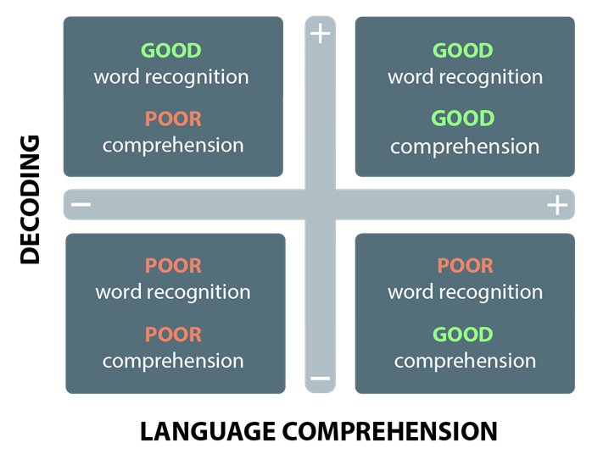
Sir Jim Rose in 2006 commissioned a national independent review on early reading. The review highlighted the importance of teaching synthetic phonics to develop reading, and the use of the ‘simple view of reading’ diagram. The simple view of reading illustrates that reading is made up of word recognition and language comprehension. This model allows us to see four different patterns of performance for children’s reading ability.
Placing children into one of the four quadrants, the simple view of reading can be applied as a framework for assessment. An example of this in practice is where a child may demonstrate good language comprehension; however, they might have poor word recognition in which case this would need to be developed.
The simple view of reading also demonstrates that reading comprehension is limited by language comprehension abilities. Children need to be able to read written texts before they can begin to understand them; however, just because a child can read the text does not necessarily mean they can understand it. Therefore, it is not only that a child needs to be able to read what is on the page, but understand what is being read in order to be a successful reader.
Copies of this model are available for the teachers to use as an assessment matrix. It provides a quick and easy method for helping to place groups of children together who may have similar needs or areas for development.

APPENDIX B – LETTERS AND SOUNDS PHONICS PHASES

Phase One
Environmental sounds, instrumental sounds, body percussion (eg clapping and stamping), rhythm and rhyme, alliteration, voice sounds, oral blending and segmenting (eg hearing that d-o-g makes ‘dog’).
Phase Two
Children begin to learn that letters make phonemes or sounds. They are taught the 19 most common phonemes. They learn how to blend and read CVC (consonant-vowel-consonant) and VC words. They also learn some common exception words.
Phase Three
Children are introduced to the remaining phonemes. This includes a wider range of digraphs and trigraphs. The children are also taught more common exception words.
Phase Four
During this phase the children are not taught any new phonemes. From now on the teaching and learning of phonics is focused consolidating the skills necessary for decoding and spelling new words. The children begin to use phonics to decode and spell much longer words. They are taught words which have adjacent consonants, including CCVC and CVCC words. The adjacent consonants can sometimes be tricky to hear or sound out, for example: milk; belt; fact. They also learn some additional common exception words.
Phase Five
A lot of time is spent learning Phase 5, therefore we split it into three sections 5a, 5b and 5c. We teach children that some graphemes can have alternative pronunciations, for example: a hard ‘c’ for cat; or a soft ‘c’ in place. The children are also shown that some phonemes can have multiple graphemes, for example: ai; ay; a_e; eigh; ey; ei. These are called alternative graphemes. They also learn more common exception words. Split digraphs are also taught.
Phase Six
Phase 6 is where children begin to build up fluency, accuracy and mastery of phonics skills taught so far. It also teaches spellings patterns, including suffixes and prefixes. The children learn less common spellings of words and graphemes. Technically once someone enters Phase 6 they never leave.

APPENDIX C – BOOK BANDS, incl. ‘WALTER LEVELS’ AGREED IN 2019

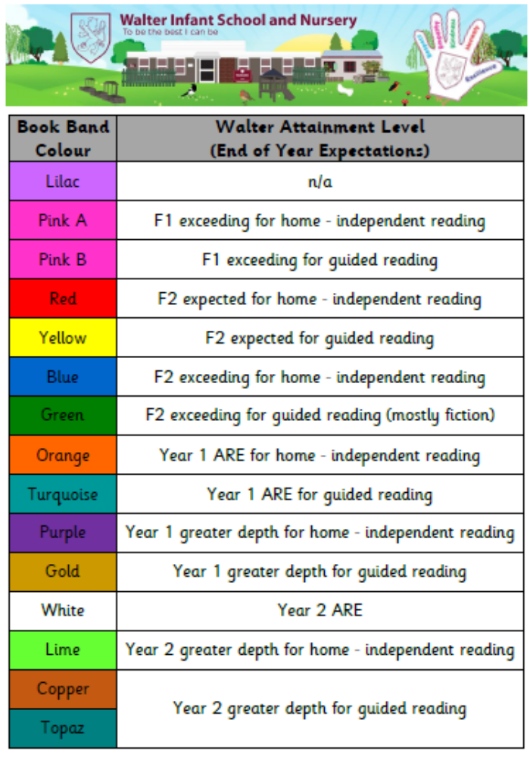
APPENDIX D – BLOOM’S TAXONOMY



