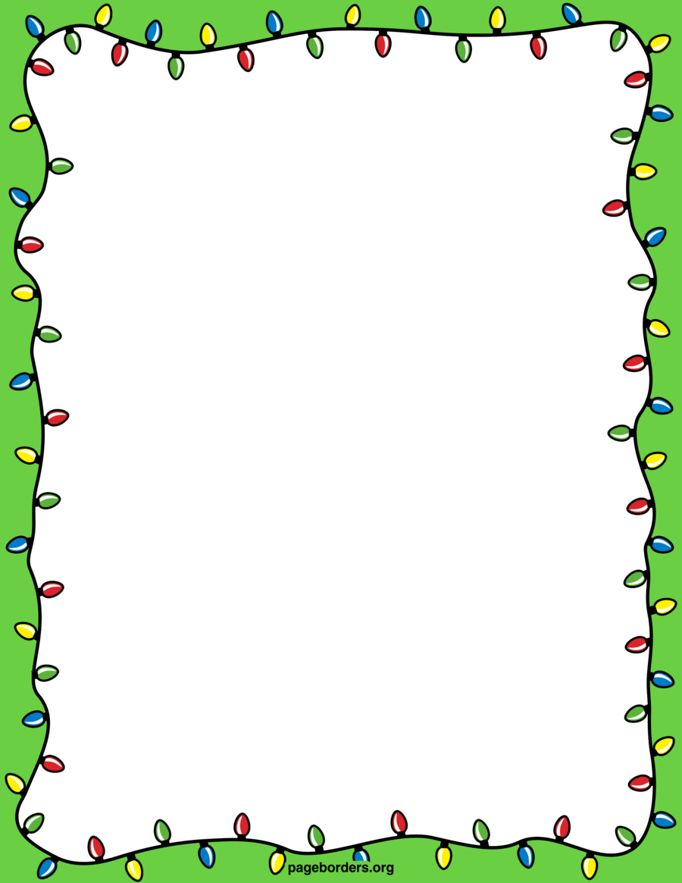

|  |
| --- |
| With best wishes from |
|  |

**Name:…………………………….Class:…………...**

**Dear Father Christmas,**

I have been: (🗸 the correct box)

|  |  |
| --- | --- |
| Extremely well behaved (as good as gold)! |  |
| Quite good (most of the time)! |  |
| I have tried hard to be good (honestly)! |  |
| Not that good, but I am still learning! |  |

**For Christmas, please may I have:**

|  |
| --- |
|  |
|  |
|  |
|  |
|  |
|  |

